REDCap logo 

COVID Employee Exposure Tracking

**Viewing a Report and Tracking Data**

1. Click on the report you’d like to view

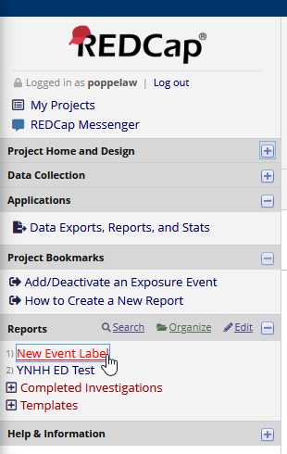

1. If you want to view or update a particular employee’s data, **click the number under Record ID**

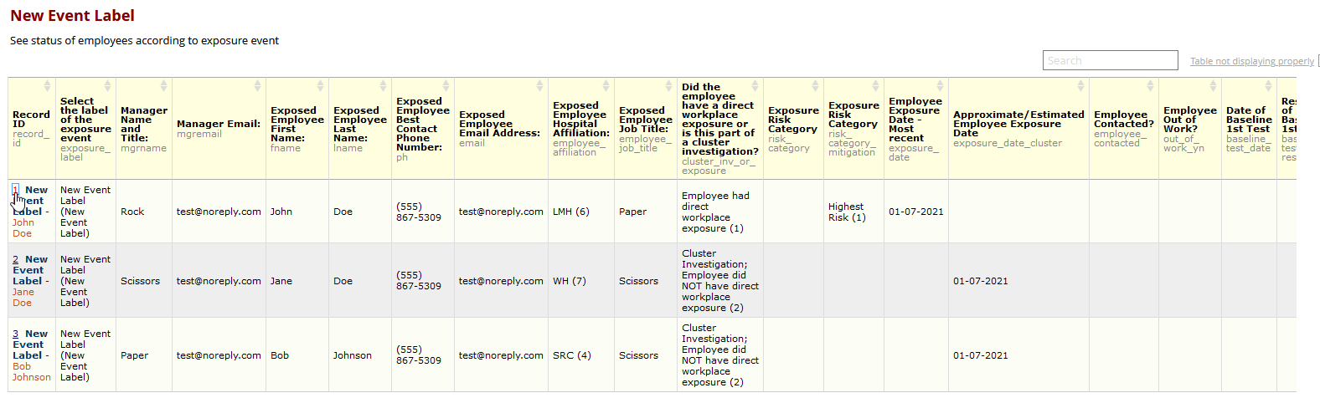

1. 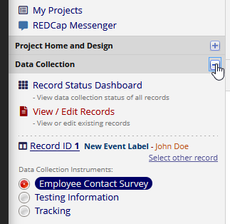Expand the **Data Collection** section to show the **Tracking** form, where you can update this employee’s information

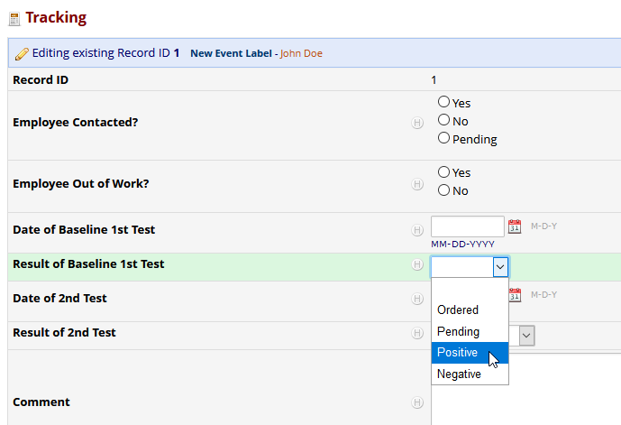**Example of updating test results:**

**Make sure to save the form ->**